Jesse Lucas

P274063

Activity 2

02/08/2020

# Assessment Title: Activity 2

## Student Name: Jesse Lucas

## Student ID: P274063

## Date: 02/09/2020

Contents

Assessment Title: Activity 2 1

Student Name: Jesse Lucas 1

Student ID: P274063 1

Date: 02/09/2020 1

Test Table 2

Debugging 3

Coding Standards 4

Class Diagram 5

Design Specifications 6

# Test Table

|  |  |  |
| --- | --- | --- |
| Add | All working | Refer to screenshot in screenshot folder |
| Delete | All Working | Refer to screenshot in screenshot folder |
| Find | All Working | Refer to screenshot in screenshot folder |
| Exit | All Working | Refer to screenshot in screenshot folder |

# Debugging

Add

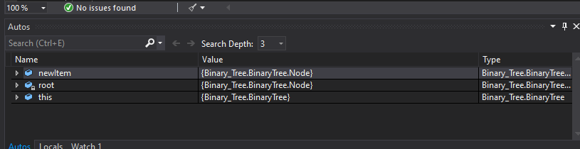

Delete

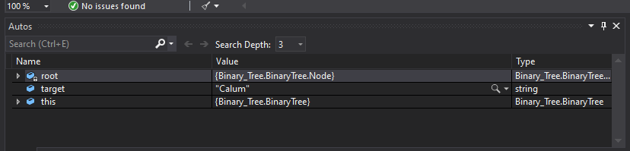

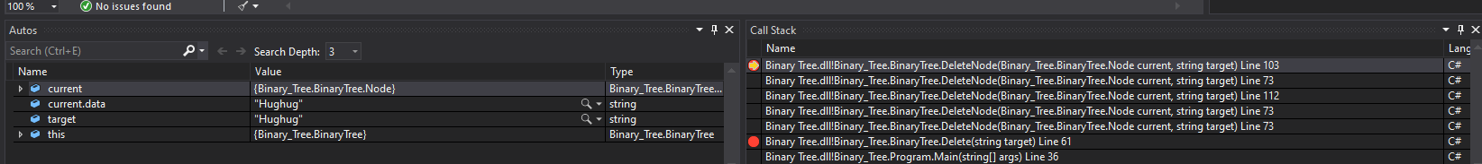

Find

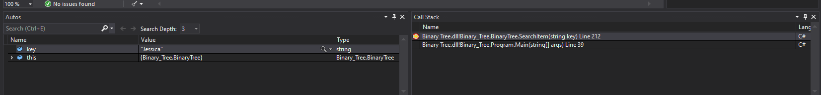

# Coding Standards

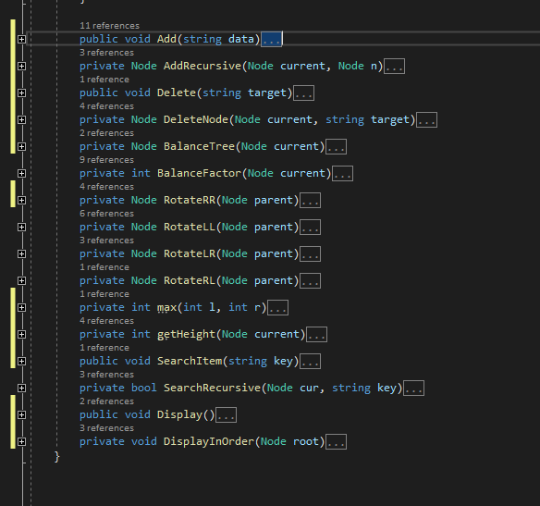

# Class Diagram

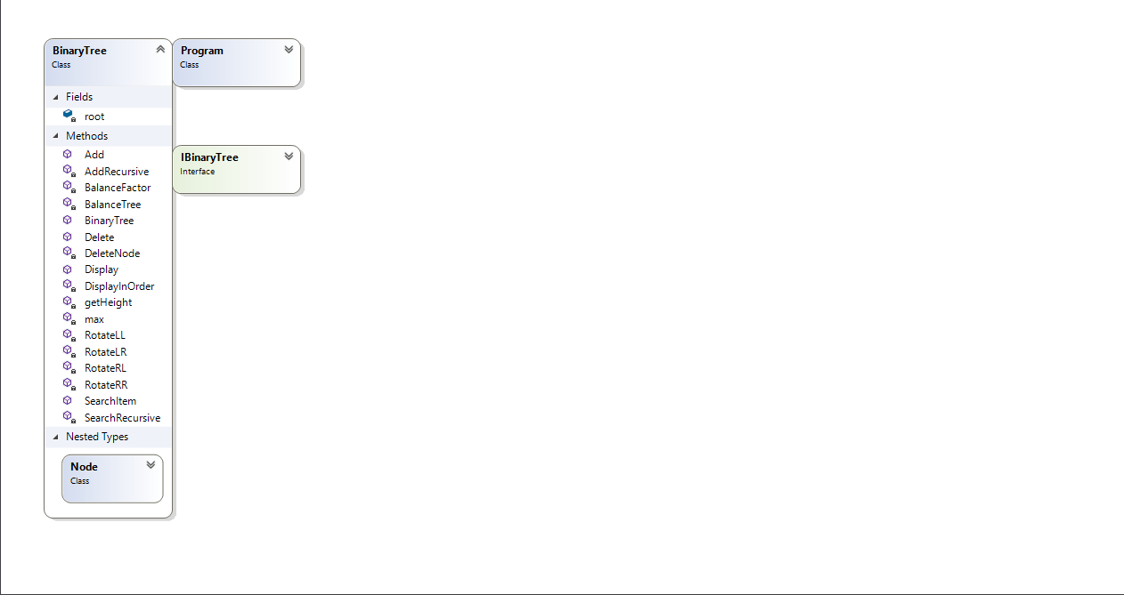

# Design Specifications

